Linear models with multiple explanatories - Study Notes
Michelle Pinard & Deon Roos
Last updated: 2025-09-04
Table of Contents

Purpose
You are able to run linear models with multiple explanatory variables. You use the same linear-model machinery (including with just one explanatory) for three broad aims: describing, predicting, and estimating a causal effect. We focussed on predicting and causation.

Core ideas
A linear model with multiple explanatory variables estimates a mean response as a sum of terms, one per predictor, plus contrasts for categorical levels.
When a continuous variable is recorded categorically (e.g., EPC or Tax bands), the model gains many parameters and loses efficiency; avoid unnecessary discretisation when you can.
Parameter estimates from a multi-variable model are associations conditional on the other explanatory variables and are not automatically causal.
Unless you use some sort of strategy (like Directed Acyclic Graphs, DAGs) to identify the causal model, then a model is most likely predictive (or descriptive).

Predictive modelling
Goal: build a model that predicts a response (e.g. rent price) from several predictors. Adding more terms is technically simple (y ~ x to y + x + z); the practical issues are interpretability and parameter growth, especially when continuous constructs are coded as categories.
Diagnostics still rely on the four plots; influential cases can be inspected by refitting without them and comparing estimates. Coefficients from the predictive model are associations useful for prediction, not causes.

Causal modelling
Goal: estimate the effect of changing one variable. Draw a DAG, apply the backdoor criterion, and fit the model implied by the adjustment set. The same lm output is then interpreted as a causal effect only under the stated DAG.
Beware the table-2 fallacy (reading every coefficient in a multivariable model as causal).

Confounding essentials
Associations can be causal, spurious, or confounded. The lecture illustrates forking, piped, and colliding structures and shows how randomisation or appropriate adjustment closes backdoor paths. Software assistance (check_dag) helps identify adjustment sets for observational data.
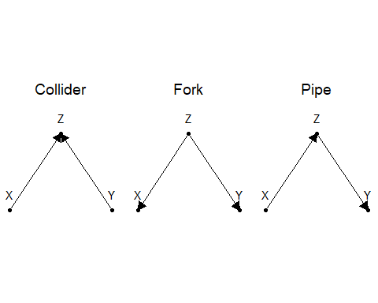
If the aim is to estimate if $x$ has a causal effect on $y$, then:
- If the confound is a collider:
  - Never include $z$
- If the confound is a fork:
  - Always include $z$
- If the confound is a pipe:
  - Never include $z$ if you want to know the total effects
  - Always include $z$ if you want to know the direct effects

Diagnostics and influence
Same diagnostic rules apply for either modelling purpose.

Interpreting parameters from predictive versus causal
- Predictive model: the FloorArea parameter is a conditional association after accounting for Rooms, EPC, and Tax.
- Causal model: the FloorArea parameter estimates the total effect under the stated DAG, which leaves mediating paths open.
Keep your interpretation aligned with the model’s purpose; predictive = “associations”, causal = “causal”.

Useful code examples
# Model with multiple explanatories
mod <- lm(y ~ x1 + x2 + f, data = df)
summary(mod)
# To create a dag and check which adjustments are required:
library(performance)
library(see)
dag <- check_dag(
y ~ x1 + x2 + f, # y is caused by x1, x2 and f
x2 ~ x1, # x2 is caused by x1
f ~ x1, # f is caused by x1
exposure = "x1", # the variable we want to estimate causal effect for
outcome = "y" # the response variable
)
plot(dag)
dag

